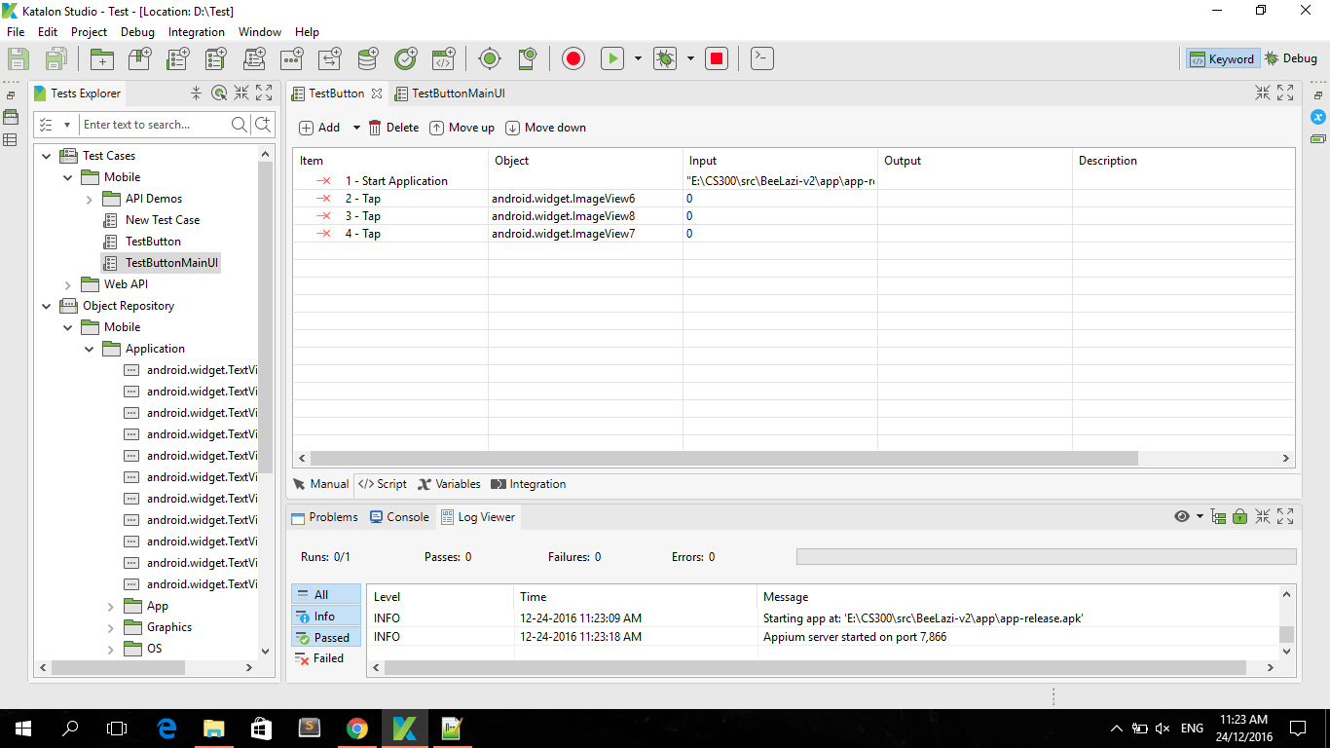Automated testing (PA5_Group 1)

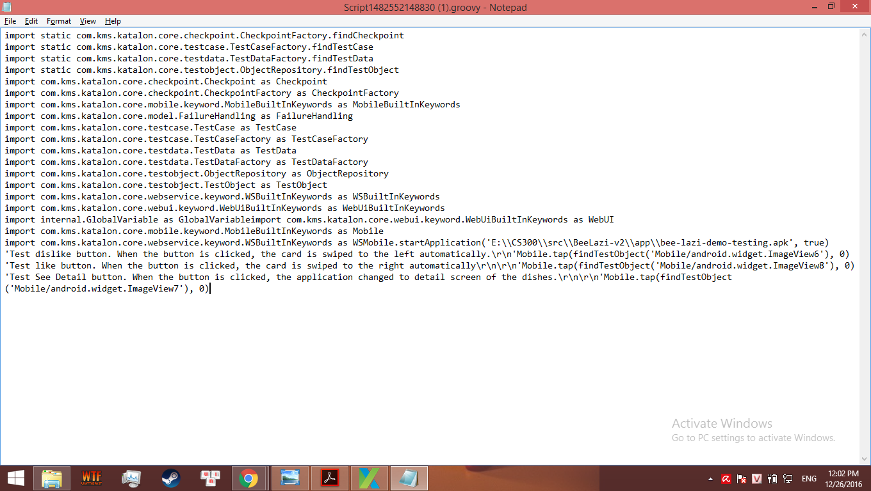

2. Why and when do we use test automation? : Because there are some steps that we have confidence in there performance and we want to check from that step without redo all over from the beginning.When we have some tests that needs to perform too many manual operations. In example: We need to perform the test on the 69th card to see whether the system can load data to the 69th card or not.